OREI HT Tomato Virtual Variety Assessment report
April 22, 2021
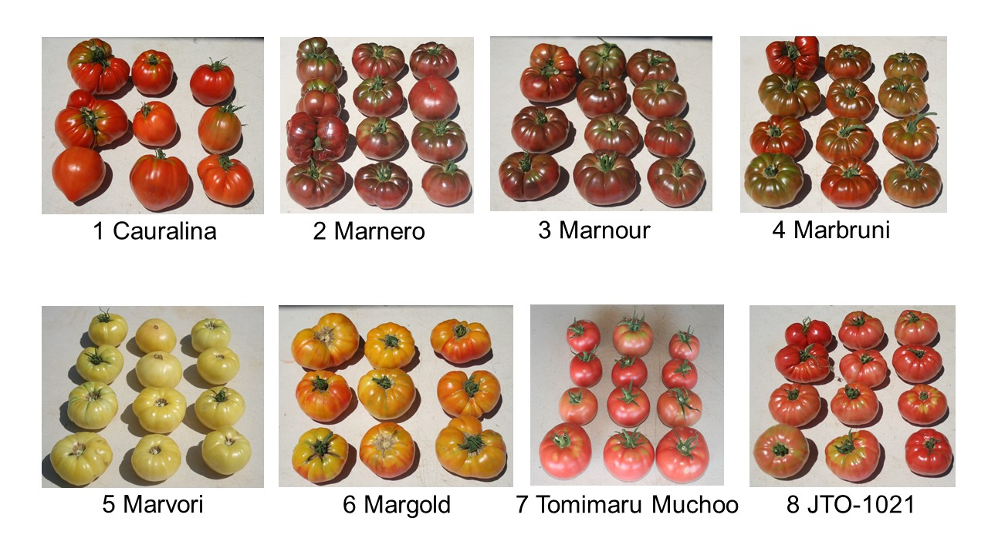
Figure 1. Photos of harvested fruit for each tomato variety and their names underneath

Participants assessed the performance of eight tomato varieties in a trial conducted in Watkinsville, GA from February 2020 through July 2020. The automated roll-up sides of the high tunnel triggered at 78ºF. We acquired seeds from Johnny’s Organic Seeds and seeded into 128-cell Speedling trays filled with Sunshine No. 3 Organic mix. We seeded in late February in a greenhouse and planted approximately 5-week old transplants in a high tunnel on 30 March 2020. We applied NatureSafe 10-2-8 at a rate of 50 lb/nitrogen/acre prior to planting in raised beds and 10-2-8 fertilizer 8 weeks after transplant at a rate of 50 lb/nitrogen/acre side-dressed for a total of 150 lb/nitrogen/acre by season end. Row spacing was 4-ft center to center with 18-inch in-row spacing. There were 8 plants per plot with 3 replicates in a randomized complete block design. We irrigated with a single line of drip irrigation per row that ran for 60-90 minutes daily. We weeded by hand and applied no insecticides or fungicides. Plants were pruned to a single central leader and strung to wires approximately 8-ft high using reel-hooks and plastic clips with weekly pruning until the second harvest. Harvest began 81 days after transplant (June 19, 2020) and continued until 120 days after transplant (July 28, 2020) with a total of eight harvests. Data included yield, yield over time, fruit size, culls, percent of culls due to blossom end rot, average fruit weight and vigor rating on plants themselves at harvest.

Participants included growers and agricultural service providers from Florida and Georgia. There were two groups of tomato varieties with four varieties per group, varieties 1-4 in group 1 and 5-8 in group 2 (see Figure 1). Participants did not know the name of the varieties while completing the assessment. Participants chose two varieties from each group to assess, using a rating system that we developed that included assessments of (1) plant vigor, (2) fruit characteristics, (3) overall plant health and (4) fruit quality. Participants ranked the four varieties they observed from top to bottom choice.

Top choice varieties:
o Marnour (4 top choices, 1 bottom choice)
o Tomimaru Muchoo (2 top choices, 1 bottom choice)

Bottom choice varieties:
o Marnero (no top choices, 2 bottom choices)
o JTO-1021 (1 top choice, 2 bottom choices)

Participants joined a facilitated discussion after completing the assessment. The participants determined the best (top choice) and worst (bottom choice) performing varieties by vote. They then moved into groups (growers and service providers) to discuss the factors that informed how they ranked tomato varieties.

Primary Factors in Determining Variety Performance

Table 1, Tomato Variety Performance Factors by Participant Category
Growers | Service Providers
Color and its consistency with fruit maturity | Color
Shape uniformity | Quality
Size consistency | Size
Presence of deformities | Plant vigor

Table 1 shows the most important tomato variety performance factors by growers and service providers. Both groups agreed that color, size and plant vigor are important tomato performance factors. The farmer group commented that Tomimaru Muchoo had an excellent deep red color and the color was consistent among mature fruit. They thought fruit shape and size were consistent and satisfactory. The farmer group noted some deformities and expressed concern regarding color and consistent maturity for variety JTO-1021, but nonetheless found this variety to be of interest. The service provider group focused on appearance in their discussion of important performance factors, particularly the color, size and quality of the fruit. This group identified plant vigor as a critical factor in determining varietal performance. Secondary factors to appearance and plant vigor were uniformity of fruit shape and foliage color. All participants engaged in an interesting discussion of the potential effects of tomato fruit that is of non-traditional in shape or even misshapen on consumer acceptance. They noted that some consumers may view this trait as an attribute of an heirloom variety. Participants agreed that there is a market for a nontraditional shaped tomato and that nontraditional shaped tomatoes are often marketed as heirloom varieties.
Participants said the virtual assessment format was challenging because they could not touch or taste the fruit.

Recommendations for Future Research
Upon completing the discussion, participants learned the names of the varieties. The facilitator asked if the research team should collect any additional data or make changes in data collection protocols. Several key concepts emerged in this discussion. Researchers commented that postharvest data would be more challenging to collect than the disease rating for each variety used in this trial. There was no disease incidence noted in this experiment.
Participants felt that lower yield would be acceptable if the variety brought a higher price point and commented that getting an ideal price might be a higher priority than total yield. However, they noted this would depend on the sales strategy of the producer and would differ for a commercial grower selling to supermarket chains versus a grower selling directly to consumers.
Participants discussed the sensitivity of tomatoes to climate and noted that high temperatures in Georgia and Florida can be detrimental to tomato production, especially in a high tunnel system. Fruit set decreases when the temperature is at or above 90°F. Participants discussed testing small fruit varieties (cherry tomatoes) because these varieties tend to set fruit better than the larger beefsteak type. There was speculation regarding the idea that smaller fruited varieties might permit production through July and August in Georgia and Florida, which would significantly extend the production period. Fruit set ended in July in this experiment.
Data Collection
- Show example of tomato fruit cut in half to see flesh
- Disease rating for each variety
- Flavor, although subjective
- Context of end user – large wholesale farm or small direct to market farm?
- Identify varieties that would bring higher price per pound
- Shelf life
- Seed to cost yield analysis
- Trial smaller varieties like cherry tomatoes

Participants then separated into groups to discuss which tomato varieties to continue, eliminate or add to future variety trials. Table 2 summarizes the responses. Overall, the grower and the service provider groups made distinct recommendations regarding tomato varieties in future experiments, although all agreed to elimination of the Cauralina variety.

Varieties to Continue, Eliminate, or Add
Table 2, Tomato Varieties to Continue, Eliminate or Add to the Trial by Participant Category
Growers | Service Providers
Continue Tomimaru Muchoo and JTO-1021 | Continue Marnero, Marnour and Marbruni
Eliminate Cauralina, Marnero and Marnour | Eliminate Margold (because fruit quality was not great), Cauralina and Tomimaru Muchoo
Add Brandywine because it is super fleshy, has a consistent shape and is good for slicing to put on a sandwich | Add Gin Fizz
 | Undecided on Marvori, Margold and JTO-1021

